SITE APPRAISAL REPORT

Site Capacity

The overall site of 0.7 Ha is located in Tinahely less than 1km to the East of the village on a greenfield site, adjacent to mixed use and residential neighbourhood. The enclosed site location plan highlights the extent of the site within the ownership of the Local Authority. The Development Plan Zoning is MU, mixed use, which should permit a proposal which includes residential of density matching the density of existing residential developments.
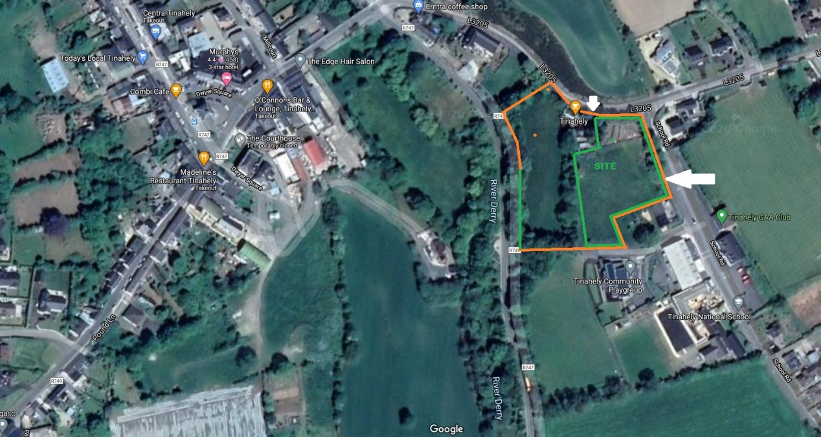
Figure 1: Aerial Image showing proposed site (green) and adjacent land use. (With Thanks to Google.)

Some landscaping and landscaping of open spaces are being incorporated into the design, the proposed development incorporated and existing well-developed playground, an existing open space. The scheme incorporates design review with Wicklow County Council planning, and also the DOEHLG Architectural Advisor.

Accommodation Brief, The proposed development of 20 units comprises of:

- 6 no. 3 Bed, 5 Person units each 89.6 sqm = ∑ 537.6msq
- 8 no. 2 Bed, 4 Person units each 75.8 sqm = ∑ 606.4msq
- 6 no. 1Bed, 2 Person units each 49.4 sqm = ∑ 296.47msq

Total proposed area = 1,440.4msq / 125msq = 11.5 units, for density calculations. The site is 0.7 Hectares. Therefore, the density for proposed development equates to, (11.5U/0.7ha=) 16.5 units per hectare.

This low density development, when considered with the retention of the community allotments on site, should be substantially compliant with the MU, mixed zoning.

In general, there is broad approval for this type of well-designed development, on this type of site, as would promote the good use of the existing services, infrastructures and facilities.

The proposal provides a good mix of dwelling types and approximates to the proportion of each dwelling size as recorded on the waiting list.
The dwellings will generally be terraced in form and floor areas, as shown above, will be consistent with the target areas of the QHfSC.

Sustainable Community Proofing

As noted the site lies within a mixed tenure, mixed income neighbourhood. It is generally accepted that 500m (5-minute walk) to 1000m (10-minute walk) represents the 'ped-shed' - a suitable distance from which residents should be able to access local services and convenience shopping. The site lies at less than 600m walk from the village.

Within 1000m (10 minutes’ walk):

- Churches
- National School
- Crèche
- Community School
- GAA Leisure Centre
- Community football pitches and GAA sports grounds.
- Village Shopping, Butchers, Pharmacy, and Convenience Stores
- Village Social amenities, café, pub, Men’s Shed, etc.

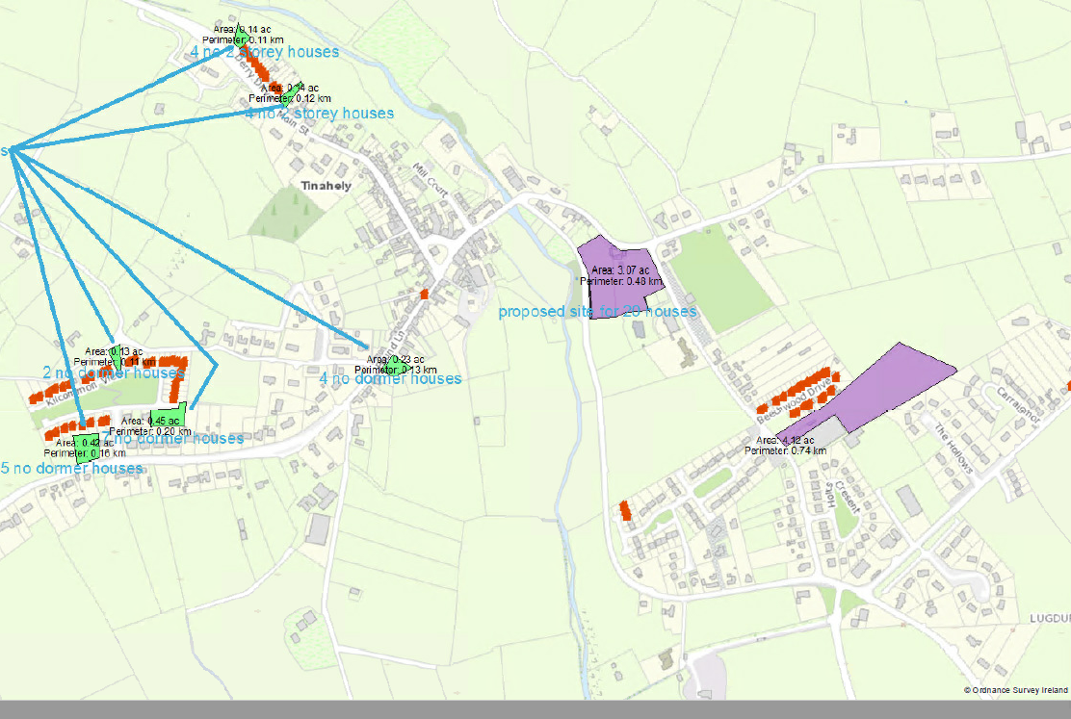
Figure 2: Map showing distribution of social housing and lands in relation to site.(WCC GIS)

Site constraints

Statutory Land Use Zoning:

In the municipal District Local Area Plan, the subject site is zoned mixed use, MU. A detailed a site investigation has been undertaken for the area of the site and preliminary designs for roads, foundations and retaining walls shall be further progressed as the design develops.

Statutory Environmental, Archaeological and Architectural Designations:

The subject site does not impact on statutory environmental designations such as Special Protection Areas (SPAs), Natural Heritage Areas (NHAs) or Special Area of Conservation (SACs). In addition the subject site does not contain any protected structure or recorded monuments.

Flood Zone:

The CFRAM Maps indicate that predicted flood levels will not impact on the development site.

Site Area

As noted previously, the area of the subject site measures approximately 0.7 Ha.

